**Chamberlin Ranch Compost Trial – 1 Year of Greenhouse Gas Emission Monitoring**

1. **Background**

Globally, soils have major potential to mitigate climate change by storing organic carbon, but realizing this potential depends on land management strategies that promote soil carbon storage. However, the effects of specific land management choices on soil carbon cycling are still unclear in many cases. Given this potential for carbon storage and the existing knowledge gaps, the State of California has created the California Healthy Soils Initiative, which “provides financial assistance for implementation of conservation management that improve soil health, sequester carbon and reduce greenhouse gas (GHG) emissions”.

Compost application could potentially influence GHG emissions in California grasslands. We expect CO2 emissions to increase due to the addition of labile organic carbon from the compost amendment, which supplies substrate for microbial respiration. Furthermore, if compost amendments stimulate primary productivity, respiration may increase as a result of additional plant-derived organic carbon inputs to soil. Additionally, compost amendments could indirectly facilitate respiration by increasing soil water-holding capacity. Soil moisture controls microbial activity, with wetter soils generally respiring more (unless they are anoxic). Previous studies of GHG emissions from California grasslands have reported increases in CO2 emission as a result of compost addition.

Additionally, we predict that compost addition could stimulate N2O emission. Compost contains organic nitrogen, which could drive nitrification, and N2O is a byproduct of nitrification. Compost addition may additionally facilitate nitrification by increasing soil water-holding capacity. As N2O is 298 times as powerful as CO2 as a greenhouse gas, it is important to quantify N2O emissions from compost application sites, in order to determine the potential for compost management strategies to mitigate climate change. However, previous studies have reported no increase in N2O emission resulting from compost application.

Compost amendments can potentially stimulate accumulation of organic carbon in soils, but these gains must be weighed against potential increases in GHG emissions. With the support of the California Healthy Soils Initiative, here we report the first year of GHG emission data from the Chamberlin Ranch experimental compost plots and make recommendations for monitoring going forward.

1. **Methods**

*Site Details*

Six trial compost sites were located at Chamberlin Ranch, near Los Olivos, CA (34°42'09"N 120°08'44"W). The study area consisted of typical California grassland and oak savannah, with an herbaceous layer consisting primarily of annual grasses and herbs, with a few perennial grasses and forbs present. Some sites contain Valley Oaks (*Quercus lobata)* and Coast Live Oaks (*Quercus agrifolia*)as well.

Trial sites consisted of adjacent, topographically similar treatment and control plots. Compost amendments were spread ¼ inch thick across each treatment plot once in autumn of 2018 and again in autumn 2019. Compost amendments were sourced from manure?

*CO2 and N2O Emission*

Greenhouse gas emissions were measured using static chambers. Corresponding treatment and control plots were sampled simultaneously, with five chambers per plot. We used plastic buckets, outfitted with plastic skirts and rubber septa in the bottom as static chambers. Buckets were placed upside-down, and plastic skirts were buried to prevent leakage. Air was sampled through the septum with a 30-mL syringe, at three time points across two hours (0, 1, and 2 hours).

Gas samples were returned to UCSB and analyzed within 1 day of sampling. CO2 concentrations were measured using an infrared gas analyzer (LICOR – XXXX). N2O concentrations were measured using a gas chromatograph with an electron capture detector. Emissions were estimated using the ideal gas law (*PV = nRT*) to estimate absolute amounts of each gas in each chamber at every sampling. We used the daily high temperatures at each site, as modeled in the PRISM climate data (PRISM Climate Group), and a pressure of 1 atm. Modeled temperatures after Aug 1, 2019 are considered preliminary in the PRISM dataset, and may be subject to change in the future

*Soil Moisture*

Soil was sampled from 0-10 cm, adjacent to each static flux chamber. Subsamples from each sample were weighed, dried at 110°C, and re-weighed. Differences in mass were assumed to be caused by evaporative water loss.

1. **Preliminary Results**

*Soil Moisture*

Soil moisture from 0-10cm varied seasonally, with site average moisture ranging from 0.0127 to 0.2935 g H2O g-1 dry soil. Soils wetter in the winter months, and drier during the summer (Fig. 1). We detected no effect of compost application on soil moisture.

*CO2 Emissions*

Mean plot-level CO2 emission estimates varied from -0.0231 to 0.7898 g CO2 m-2 hr-1 (Fig 2.). Emissions varied seasonally with soil moisture. We have not observed any effect of compost treatments on CO2 emissions.

*N2O Emissions*

Mean plot-level N2O emissions estimates ranged from -1.832e-05 to 1.676e-05 g N2O m-2 hr-1. Emissions varied very little, and were close to zero in all months of the year. We have not detected any effect of compost application on N2O emissions.

1. **Discussion and Recommendations**

Contrary to our expectations, we detected no effect of compost treatments on soil moisture, CO2 emission, or N2O emissions. Soil moisture varied seasonally, and CO2 emission appeared to vary with soil moisture, while functionally zero N2O emissions were detected across the year. Our inability to detect effects of compost on any of these variables could be explained in two ways – either **A)** no effect exists, or **B)** our sampling regime is insufficient to detect any extant effect.

We expected to observe a positive effect of compost on soil moisture, due to previous reports of increased water-holding capacity in compost-amended soils. This effect may be absent in the Chamberlin Ranch compost plots from 0-10cm depth due to the relatively thin layer (1/4 in = 0.635cm) of compost applied; any effect may be muted by measuring moisture to 10cm. Additionally, even if amended soils have higher water-holding capacity, the effect of increased water-holding capacity on actual soil water content may only be apparent during certain seasons (i.e. the “dry-down” period of late spring).

We also expected to observe a positive effect of compost on CO2 emission. Compost amendments provide an influx of labile organic matter, which could supply material for microbial respiration. Other studies of compost in northern California grasslands have reported increased soil respiration in compost-treated plots. However, we detected no effect of compost amendments on CO2 emission. This may be due to the relatively thin layer of compost that was applied – any effect may be too small to detect. Alternatively, the presence of additional labile organic matter may be insufficient to stimulate respiration in this system. Soil moisture is a major control of respiration, and southern California grasslands typically receive less rainfall than their northerly counterparts. Therefore, soil moisture may be a more limiting for respiration in these systems, and the amount of available labile organic matter may be less important.

We also hypothesized that compost amendments might lead to increases in N2O emissions. Compost amendments supply organic nitrogen to soils, which can drive increases in rates of nitrification. As N2O is a byproduct of nitrification, compost could stimulate N2O production. However, we did not observe an effect of compost amendments on N2O emission – in fact, we observed very little to no N2O emission at all. The lack of a compost-driven effect on N2O emission may be due to the small quantity of compost that was applied – it may not contain enough nitrogen to drive meaningful increases in nitrification. Alternatively, our sampling schedule may not be sufficient to detect releases in N2O emissions. N2O emissions are highly temporally variable, and typically occur in pulses corresponding with soil wet-up. We have yet been unable to sample during a wet-up event, so it is possible that we are missing any effects that compost may have on N2O emission.

*Recommendations*

CO2 and N2O emissions are controlled by soil moisture. Given our confirmation of this phenomenon in the Chamberlin Ranch compost trial plots, we recommend focusing gas flux sampling accordingly. We should restrict gas flux sampling to the winter season when the soil contains enough water to support microbial activity. Measurement of N2O should be restricted to samples taken during and soon after soil wet-up events.

1. **Figures**

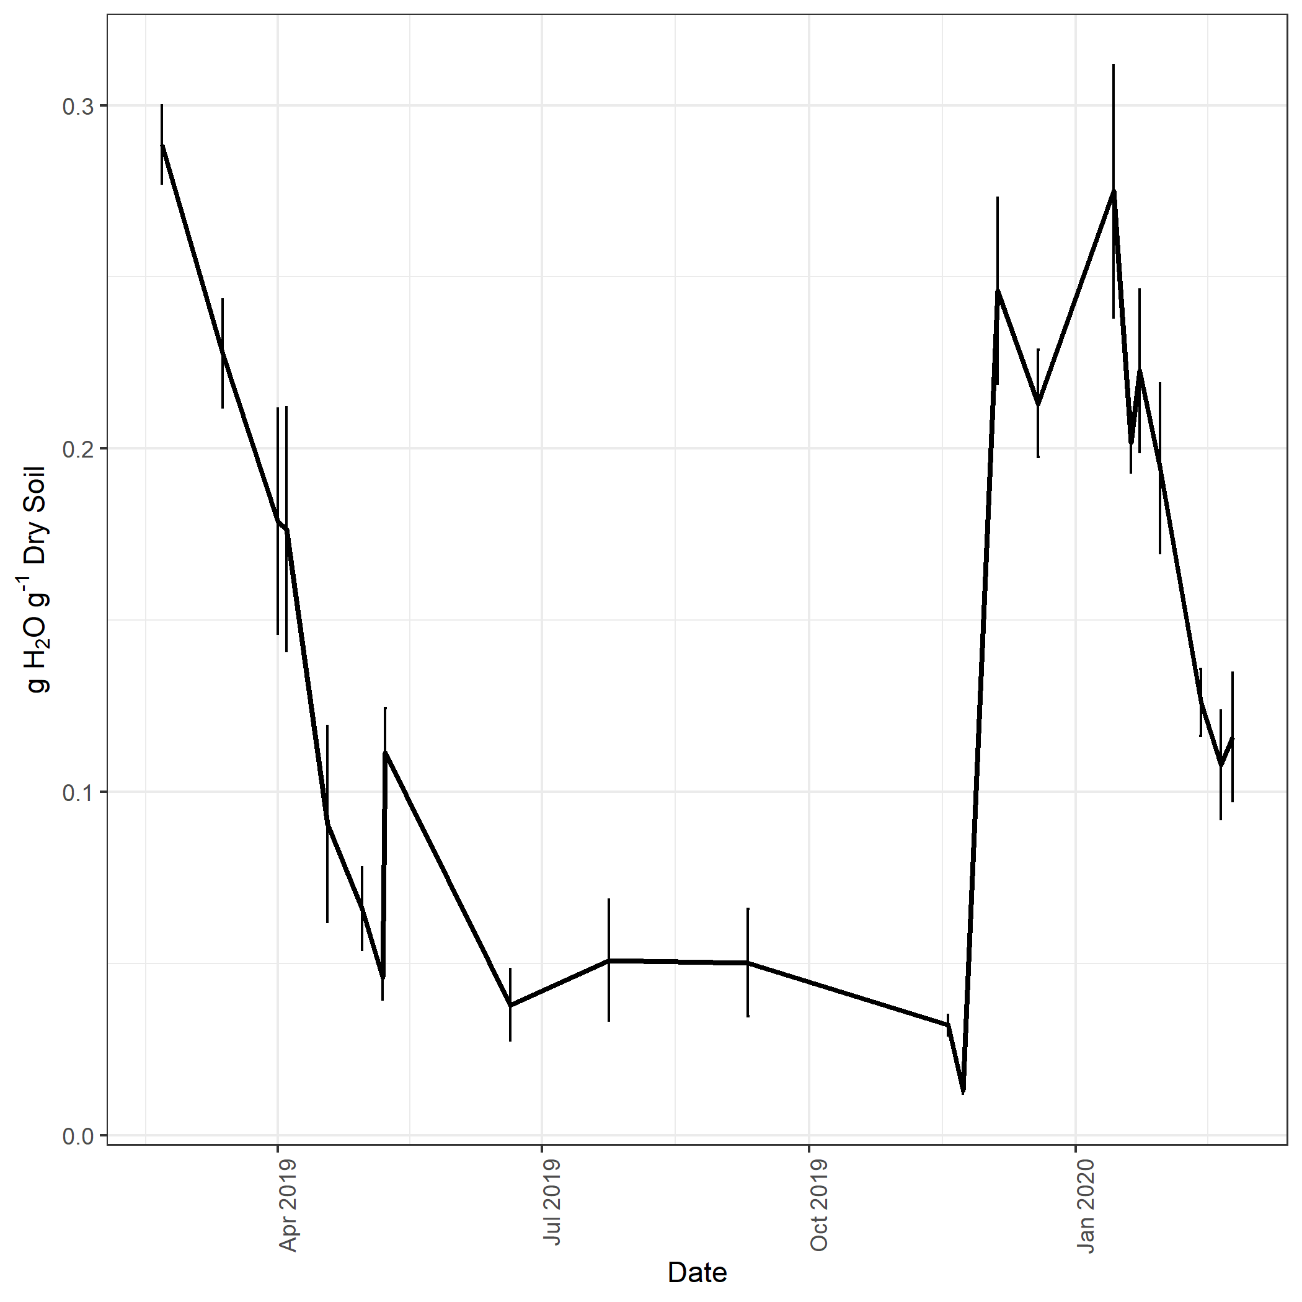

Figure 1 – Average soil moisture from all plots from February 2019 to February 2020. Vertical lines represent error bars for soil moisture on each sampling date.

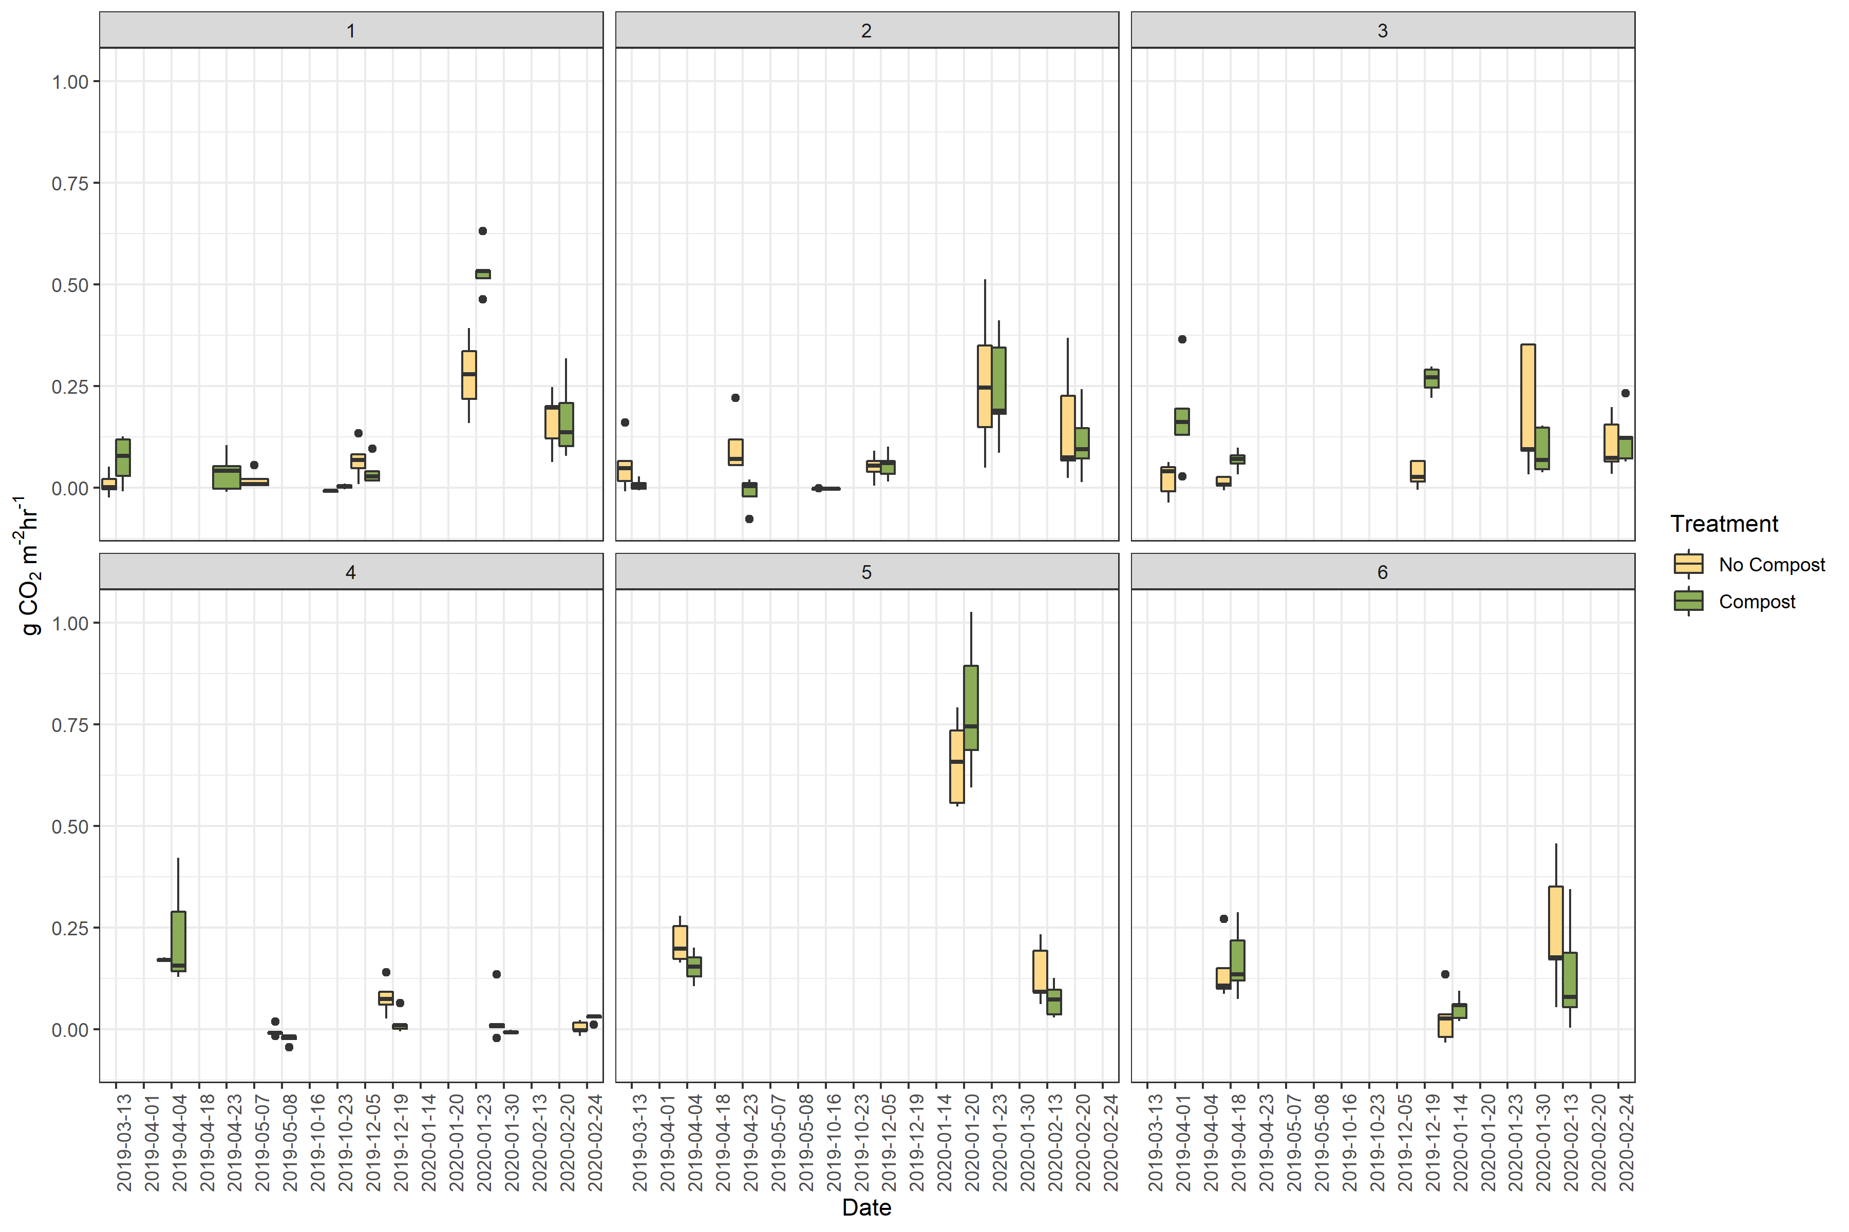

Figure 2 – Boxplot of CO2 emission measurements for control and treatment plots on each date of sampling. Each panel represents a different test site (1-6).

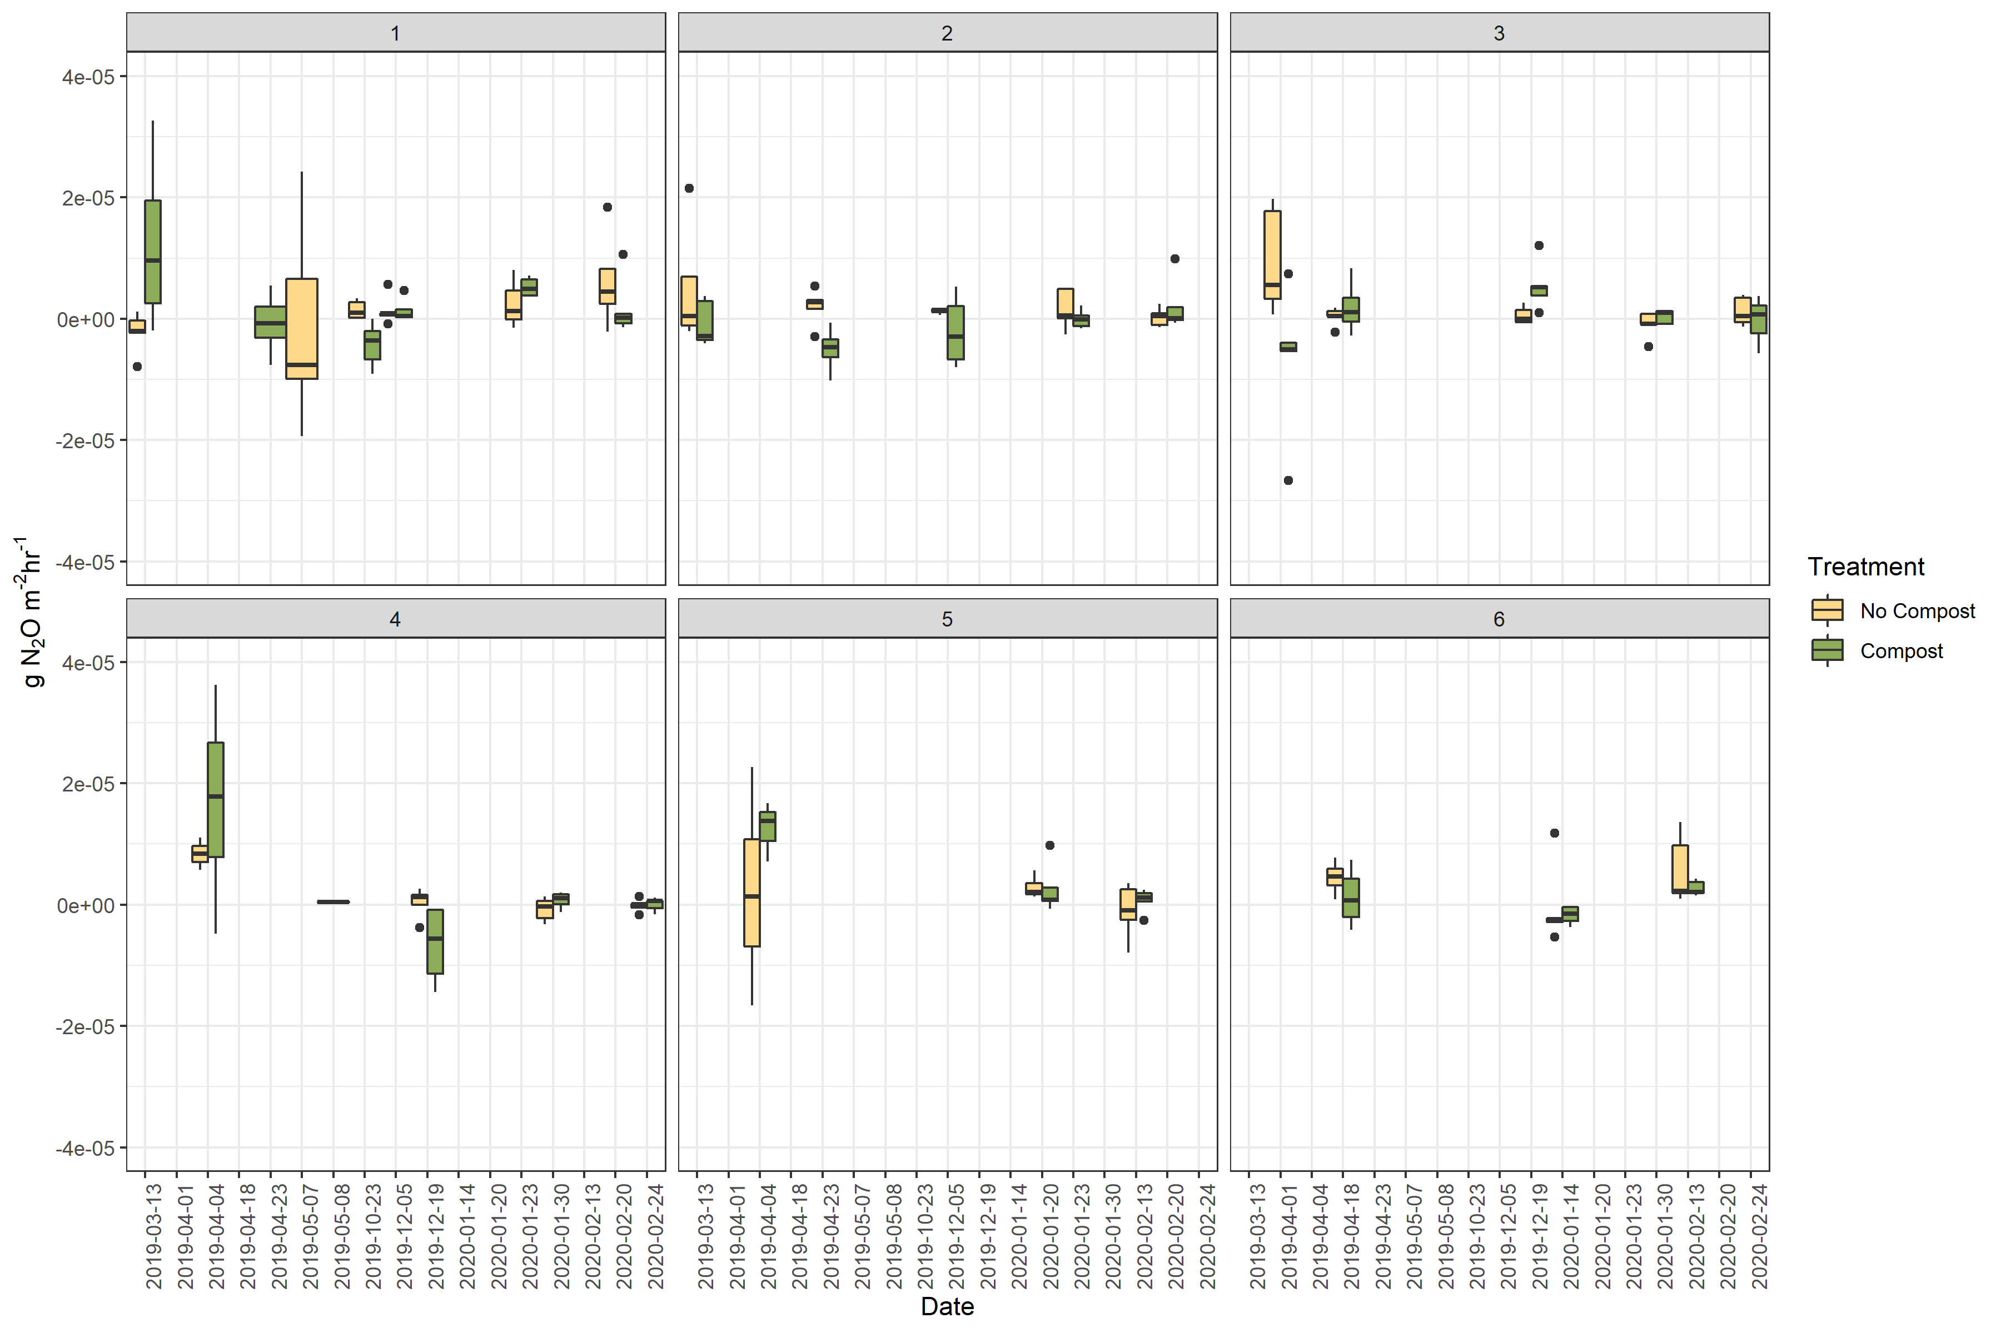

Figure 3 - Boxplot of N2O emission measurements for control and treatment plots on each date of sampling. Each panel represents a different test site (1-6).

1. **Citations**

PRISM Climate Group, Oregon State University, http://prism.oregonstate.edu, created 25 Feb 2020